WEEK7 REACT

Exercise 1 : Create a React Application named “cricketapp” with the following components:

1. ListOfPlayers
2. IndianPlayers

App.js

import React from 'react';

import ListofPlayers from './ListofPlayers';

import IndianPlayers from './IndianPlayers';

function App() {

  const flag = true;

  return (

    <div className="App">

      <h1>🏏 Cricket App</h1>

      {flag ? <ListofPlayers /> : <IndianPlayers />}

    </div>

  );

}

export default App;

ListofPlayers.js

import React from 'react';

function ListofPlayers() {

  const players = [

    { name: "Virat", score: 95 },

    { name: "Rohit", score: 88 },

    { name: "Gill", score: 66 },

    { name: "Rahul", score: 42 },

    { name: "Iyer", score: 70 },

    { name: "Hardik", score: 85 },

    { name: "Jadeja", score: 69 },

    { name: "Shami", score: 75 },

    { name: "Bumrah", score: 60 },

    { name: "Kuldeep", score: 35 },

    { name: "Siraj", score: 55 },

  ];

  const filteredPlayers = players.filter(player => player.score < 70);

  return (

    <div>

      <h2>All Players (map)</h2>

      <ul>

        {players.map((player, index) => (

          <li key={index}>{player.name} - {player.score}</li>

        ))}

      </ul>

      <h3>Filtered Players (Score &lt; 70)</h3>

      <ul>

        {filteredPlayers.map((player, index) => (

          <li key={index}>{player.name}</li>

        ))}

      </ul>

    </div>

  );

}

export default ListofPlayers;

IndianPlayers.js

import React from 'react';

function IndianPlayers() {

  const T20Players = ["Virat", "Rohit", "Suryakumar", "Hardik"];

  const RanjiTrophyPlayers = ["Pujara", "Rahane", "Jadeja", "Ishant"];

  const allPlayers = [...T20Players, ...RanjiTrophyPlayers];

  const oddTeam = allPlayers.filter((_, index) => index % 2 !== 0);

  const evenTeam = allPlayers.filter((_, index) => index % 2 === 0);

  return (

    <div>

      <h2>Merged Players:</h2>

      <ul>

        {allPlayers.map((player, index) => (

          <li key={index}>{player}</li>

        ))}

      </ul>

      <h2>Even Team (Destructuring)</h2>

      <ul>

        {evenTeam.map((player, index) => (

          <li key={index}>{player}</li>

        ))}

      </ul>

      <h2>Odd Team (Destructuring)</h2>

      <ul>

        {oddTeam.map((player, index) => (

          <li key={index}>{player}</li>

        ))}

      </ul>

    </div>

  );

}

export default IndianPlayers;

O/P

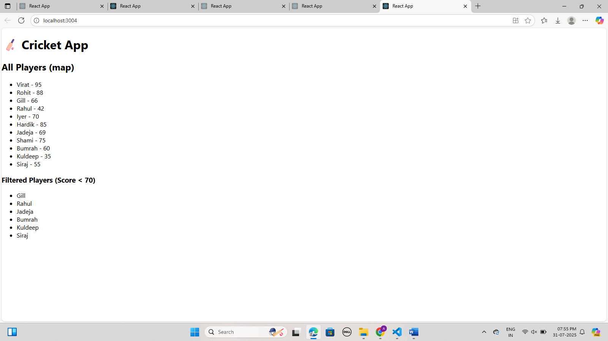

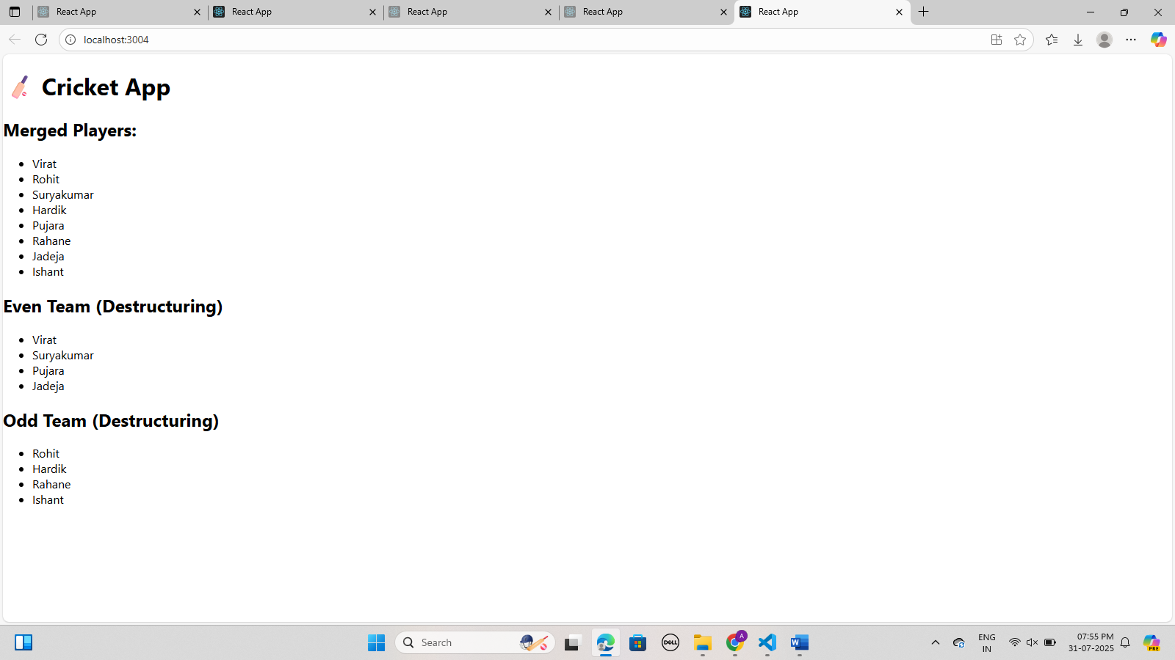

Exercise 2: Create a React Application named “officespacerentalapp” which uses React JSX to create elements, attributes and renders DOM to display the page.

App.js

import React from 'react';

import './App.css';

function App() {

  const offices = [

    { name: "SpaceOne", rent: 55000, address: "Chennai" },

    { name: "WorkHub", rent: 75000, address: "Bangalore" },

    { name: "OfficeNest", rent: 62000, address: "Hyderabad" },

  ];

  return (

    <div>

      <h1>Office Space Rentals</h1>

      <img src="./image.webp" alt="Office" />

      <ul>

        {offices.map((office, index) => (

          <li key={index}>

            <strong>{office.name}</strong> - ₹<span style={{ color: office.rent < 60000 ? "red" : "green" }}>{office.rent}</span> <br />

            Address: {office.address}

          </li>

        ))}

      </ul>

    </div>

  );

}

export default App;

O/P

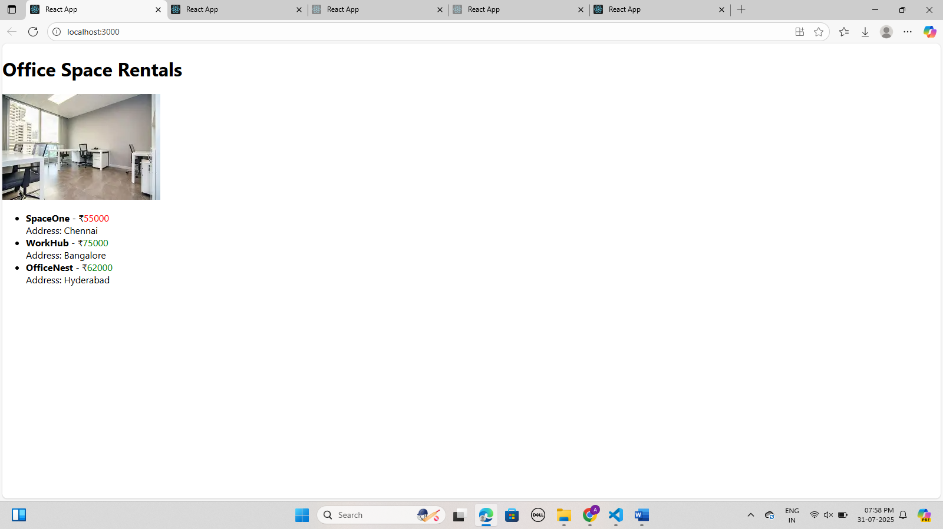

Exercise 3: Create a React Application “eventexamplesapp” to handle various events of the form elements in HTML.

App.js

import React, { useState } from 'react';

function App() {

  const [count, setCount] = useState(0);

  const [message, setMessage] = useState("");

  const increment = () => {

    sayHello();

    setCount(count + 1);

  };

  const decrement = () => setCount(count - 1);

  const sayHello = () => setMessage("Hello! Counter incremented.");

  const sayWelcome = (msg) => setMessage(msg);

  const handleClick = (e) => setMessage("I was clicked");

  return (

    <div>

      <h2>Count: {count}</h2>

      <button onClick={increment}>Increment</button>

      <button onClick={decrement}>Decrement</button>

      <button onClick={() => sayWelcome("Welcome!")}>Say Welcome</button>

      <button onClick={handleClick}>OnPress</button>

      <h3>{message}</h3>

      <CurrencyConvertor />

    </div>

  );

}

function CurrencyConvertor() {

  const [rupee, setRupee] = useState('');

  const [euro, setEuro] = useState('');

  const handleConvert = () => {

    setEuro((parseFloat(rupee) / 90).toFixed(2));

  };

  return (

    <div>

      <h3>Currency Convertor</h3>

      <input type="number" value={rupee} onChange={(e) => setRupee(e.target.value)} placeholder="INR" />

      <button onClick={handleConvert}>Convert to Euro</button>

      <p>Euro: €{euro}</p>

    </div>

  );

}

export default App;

O/P

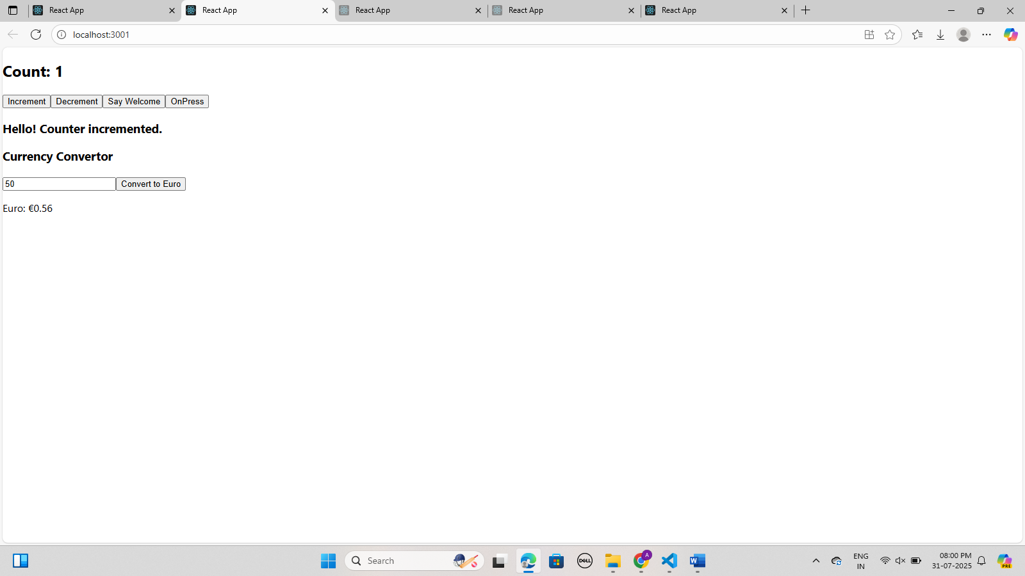

Exercise 4: Create a React Application named “ticketbookingapp” where the guest user can browse the page where the flight details are displayed whereas the logged in user only can book tickets.

App.js

import React, { useState } from 'react';

function App() {

  const [loggedIn, setLoggedIn] = useState(false);

  const toggleLogin = () => setLoggedIn(!loggedIn);

  return (

    <div>

      <button onClick={toggleLogin}>

        {loggedIn ? "Logout" : "Login"}

      </button>

      {loggedIn ? <UserPage /> : <GuestPage />}

    </div>

  );

}

const GuestPage = () => (

  <div>

    <h2>Welcome Guest!</h2>

    <p>Browse flight details here.</p>

  </div>

);

const UserPage = () => (

  <div>

    <h2>Welcome User!</h2>

    <p>You can now book tickets.</p>

  </div>

);

export default App;

O/P

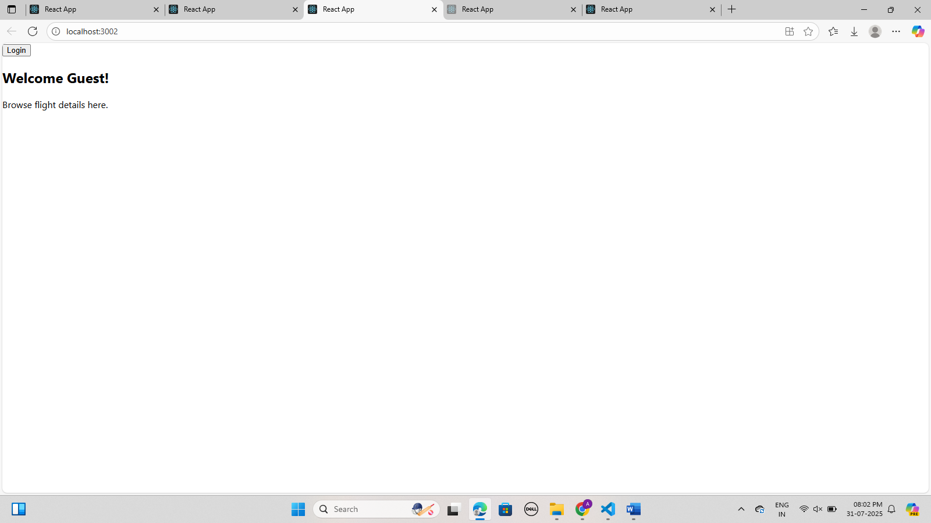

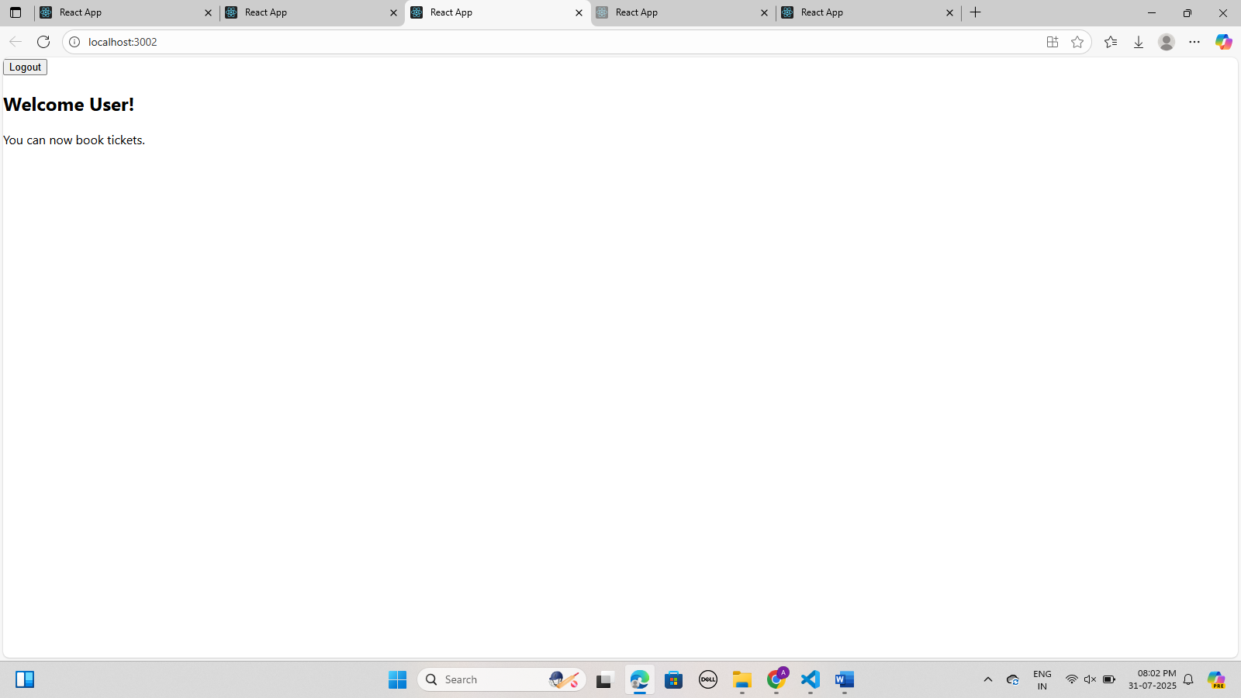

Exercise 5: Create a React App named “bloggerapp” in with 3 components.

1. Book Details
2. Blog Details
3. Course Details

Implement this with as many ways possible of Conditional Rendering.

App.js

import React, { useState } from 'react';

import BookDetails from './BookDetails';

import BlogDetails from './BlogDetails';

import CourseDetails from './CourseDetails';

function App() {

  const [section, setSection] = useState("book");

  let content;

  if (section === "book") {

    content = <BookDetails />;

  } else if (section === "blog") {

    content = <BlogDetails />;

  } else if (section === "course") {

    content = <CourseDetails />;

  }

  return (

    <div className="App">

      <h1>Blogger App</h1>

      <div>

        <button onClick={() => setSection("book")}>Book</button>

        <button onClick={() => setSection("blog")}>Blog</button>

        <button onClick={() => setSection("course")}>Course</button>

      </div>

      <hr />

      <h2>1. If-Else (Element Variable):</h2>

      {content}

      <h2>2. Ternary Operator:</h2>

      {section === "book" ? <BookDetails /> : <p>This is not the Book section.</p>}

      <h2>3. Logical AND (&&):</h2>

      {section === "course" && <CourseDetails />}

    </div>

  );

}

export default App;

BlogDetails.js

import React from 'react';

function BlogDetails() {

  return (

    <div>

      <h3>Blog Details</h3>

      <p>Blog Topic: React Conditional Rendering</p>

      <p>Author: Akkash Dalmetha</p>

    </div>

  );

}

export default BlogDetails;

BookDetails.js

import React from 'react';

function BookDetails() {

  return (

    <div>

      <h3>Book Details</h3>

      <p>Book Title: React Explained</p>

      <p>Author: Daniel</p>

    </div>

  );

}

export default BookDetails;

CourseDetails.js

import React from 'react';

function CourseDetails() {

  return (

    <div>

      <h3>Course Details</h3>

      <p>Course: Full Stack Development</p>

      <p>Duration: 3 Months</p>

    </div>

  );

}

export default CourseDetails;

O/P

